MAIN TEXT

TITLE: INDIA’S HIDDEN DISEASE: RETROSPECTIVE STUDY OF HANSEN DISEASE IN A TERTIARY CARE HOSPITAL

Dear Sir,

We intend to publish an article entitled “INDIA’S HIDDEN DISEASE: RETROSPECTIVE STUDY OF HANSEN DISEASE IN A TERTIARY CARE HOSPITAL
” in your journal as a Original article. On behalf of all the authors, I will act and guarantor and will correspond with the journal from this point onward.
All authors of this manuscript declare that this manuscript represents valid work and that neither this manuscript nor one with substantially similar content under the present authorship has been published or is being considered for publication elsewhere and the authorship of this article will not be contested by anyone whose name(s) is/are not listed here, and that the order of authorship as placed in the manuscript is final and accepted by the co-authors. Each author also acknowledges that this final version was read and approved.
We certify that all the data collected during the study is presented in this manuscript and no data from the study has been or will be published separately. We attest that, if requested by the editors, we will provide the data/information or will cooperate fully in obtaining and providing the data/information on which the manuscript is based, for examination by the editors or their assignees.
We also certify that we have taken all necessary permissions from our institution and/or department for conducting and publishing the present work. There is no ethical problem or conflict of interest.

We have read the all policies including Copyright Policy of the Journal and agree to abide by the same in the event such work is published by the journal.

ACKNOWLEDGEMENTS:
1)Dr.Vimal chander,Associate professor ,Department of Pathology,Saveetha Medical College
2)Dr.Chitra Srinivasan: Professor and Head of the Department,Deparment of Pathology, Saveetha Medical College
FUNDING: Self
COMPETING INTERESTS: N/A

REFERENCE:
- Jay, V. (2000). The legacy of Armauer Hansen. Archives of Pathology and Laboratory Medicine, 124(4), 496–497
- Avninder Singh, Xiaoman Weng and Indira Nath (2011). Skin Biopsy in Leprosy, Skin Biopsy – Perspectives
- Nadia, S., Rashmi, J., Sohaib, A., Rawat, S.D.S., Thamarai, S.N., and Meena, H. (2015). Clinico pathological correlation of leprosy: a 4 years retrospective study from a tertiary referral centre in north india. International journal of medical research & health sciences 4, 350–354.
- Tiwari M, Ranabhat S, Maharjan S. Clinicohistopathological correlation of leprosy: A retrospective study of skin biopsy specimens in Chitwan Medical College. Inter J Medical Sci Res Prac 2015;2(1):8-11.
- NICRO (2016). NICRO Annual Report 2015 - 2016.

FIGURE WITH LEGENDS
Fig 1:
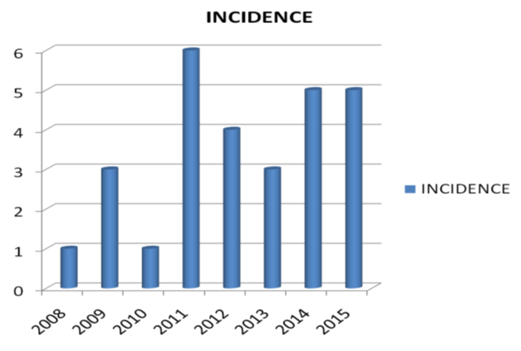
Incidence of cases with leprosy from the year 2008 to 2015
FIG 2:
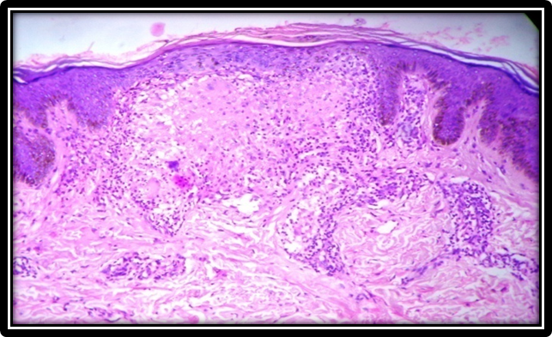
10X, H and E:subepidermal well defined granuloma

FIG 3:
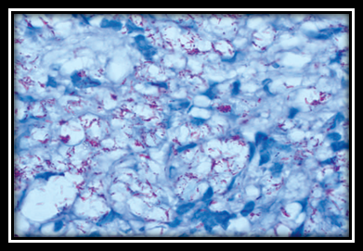
AFB,Oil immersion,100-1000 bacilli in one OIF (5+).A case of lepromatous leprosy.

TABLES:
Table 1:
Table 1: Bacteriological Index⁴

GRADE | BACILLI/Oil immersion field (OIF)
1+ | 1-10bacilli in 100 OIF
2+ | 1-10 bacilli in 10 OIF
3+ | 1-10 bacilli in 1 OIF
4+ | 10-100bacilli in 1 OIF
5+ | 100-1000 bacilli in 1 OIF
6+ | ≥1000 bacilli in 1 OIF

Table 2: Classification of Hansens disease3.
Group | Features
Indeterminate | Lymphocytes and histiocytes localized around skin structures. AFB shows scanty bacilli
Tuberculoid Leprosy (TL) | Show epithelioid granuloma with lanhans giant cells surrounded by dense lymphocytic infiltrate.Nerve infiltration is present. AFB is negative
Borderline Tuberculoid (BT) | Clear subepidermal zone with epithelioid granuloma surrounded by peripheral lymphocytes and Langhans giant cells. AFB may or may not be seen
Borderline (BB) | Presence of subepidermal clear zone with epithelioid granulomas and diffusely spread lymphocytes. AFB is usually seen.
Borderline Leprosy (BL) | Loose ill defined granulomas composed of histiocytic cells with dense lymphocytic infiltrate. AFB usually seen.
Lepromatous leprosy (LL) | Histiocytes and foamy macrophages are seen. Lymphocytes are scanty .Grenz zone is present.AFB Is numerous
Histoid Leprosy (HL) | Nodular form of leprosy, Microscopy shows spindle shaped cells with predominant histiocytes. AFB is numerous.

Table 3: SPECTRUM OF CLINICAL DIAGNOSIS
CLINICAL DIAGNOSIS | CASES | PERCENTAGE
INDETERMINATE | 1 | 3%
TUBERCULOID | 4 | 14%
BORDERLINE TUBERCULOID | 12 | 43%
MIDBORDERLINE | 0 | 0%
BORDERLINE LEPROMATOUS | 3 | 11%
LEPROMATOUS LEPROSY | 4 | 14%
HISTOID LEPROSY | 1 | 4%
OTHERS | 3 | 11%
TOTAL | 28 | 100%

Table 4: Spectrum of histopathological diagnosis
Histopthological diagnosis | Case No | Percentage
Indeterminate | 3 | 11
Tuberculoid Leprosy | 4 | 14%
Borderline tuberculoid | 8 | 29%
Mid borderline | 2 | 7%
Borderline lepromatous | 5 | 18%
Lepromatous leprosy | 5 | 18%

TABLE5: CLINICAL AND HISTOPATHOLOGICAL CORRELATION
HPE cases | Correlating | Noncorrelating | Correlation %
Indeterminate | 1 | 2 | 33.3
Tuberculoid leprosy | 2 | 2 | 50
Borderline tuberculoid | 7 | 1 | 87.5%
Borderline borderline | 0 | 2 | 0
Borderline lepromatous | 3 | 2 | 60
Lepromatous leprosy | 2 | 3 | 40
Histoid leprosy | 0 | 1 | 0
Overall correlation | 15 | 13 | 53.6%

TABLE 6 :Fite Farraco correlation
FITE FARACO | TUBERCULOID SPECTRUM | LEPROMATOUS SPECTRUM
PRESENT | 3 | 10
ABSENT | 9 | 1
TOTAL | 12 | 11

