MAIN TEXT

TITLE: RETROSPECTIVE STUDY OF SPECTRUM OF OVARIAN TUMOURS IN A TERTIARY CARE SETUP

Dear Sir,
We intend to publish an article entitled “Retrospective study of spectrum of ovarian tumours in a tertiary care set up”in your journal as a Original article On behalf of all the authors, I will act and guarantor and will correspond with the journal from this point onward.
All authors of this manuscript declare that this manuscript represents valid work and that neither this manuscript nor one with substantially similar content under the present authorship has been published or is being considered for publication elsewhere and the authorship of this article will not be contested by anyone whose name(s) is/are not listed here, and that the order of authorship as placed in the manuscript is final and accepted by the co-authors. Each author also acknowledges that this final version was read and approved.
We certify that all the data collected during the study is presented in this manuscript and no data from the study has been or will be published separately. We attest that, if requested by the editors, we will provide the data/information or will cooperate fully in obtaining and providing the data/information on which the manuscript is based, for examination by the editors or their assignees.
We also certify that we have taken all necessary permissions from our institution and/or department for conducting and publishing the present work. There is no ethical problem or conflict of interest.

We have read the all policies including Copyright Policy of the Journal and agree to abide by the same in the event such work is published by the journal.

ACKNOWLEDGEMENTS:
Dr.Vimal Chander (Associate professor)
Dr.Chitra Srinivasan (Professor and HOD),Department of Pathology

FUNDING: self
COMPETING INTERESTS:

REFERENCE:
1: Robbins and Cotran, Pathologic basis of disease 9th edition
2.Parkin DM et al;Global cancer statistics 2002;CA cancer J clin 2005,55:74-108
3: Consolidated report of population based cancer registries 2001- 2004. National Cancer Registry Program. Indian council of medical research. Bangalore 2006
4. Jemal A,Siegal R et al Cancer statistics, 2006 CA Cancer JClin 2006;56:106-30
5. Changing trends in incidence of ovarian cancer –The Indian scenario June 2009 Asian Pacific journal of Cancer prevention

FIGURE WITH LEGENDS

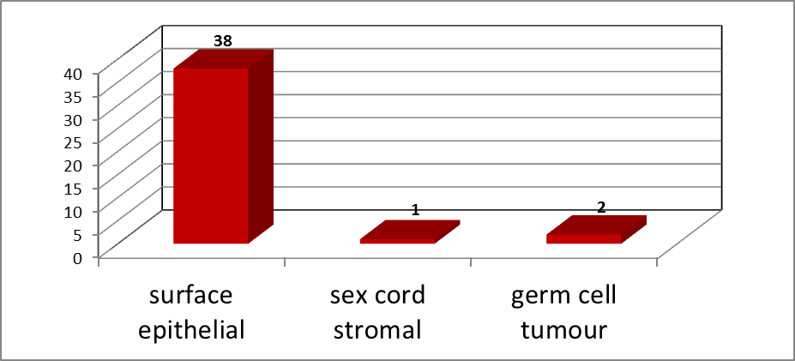
Figure 1: Benign, malignant and borderline tumors in different age groups
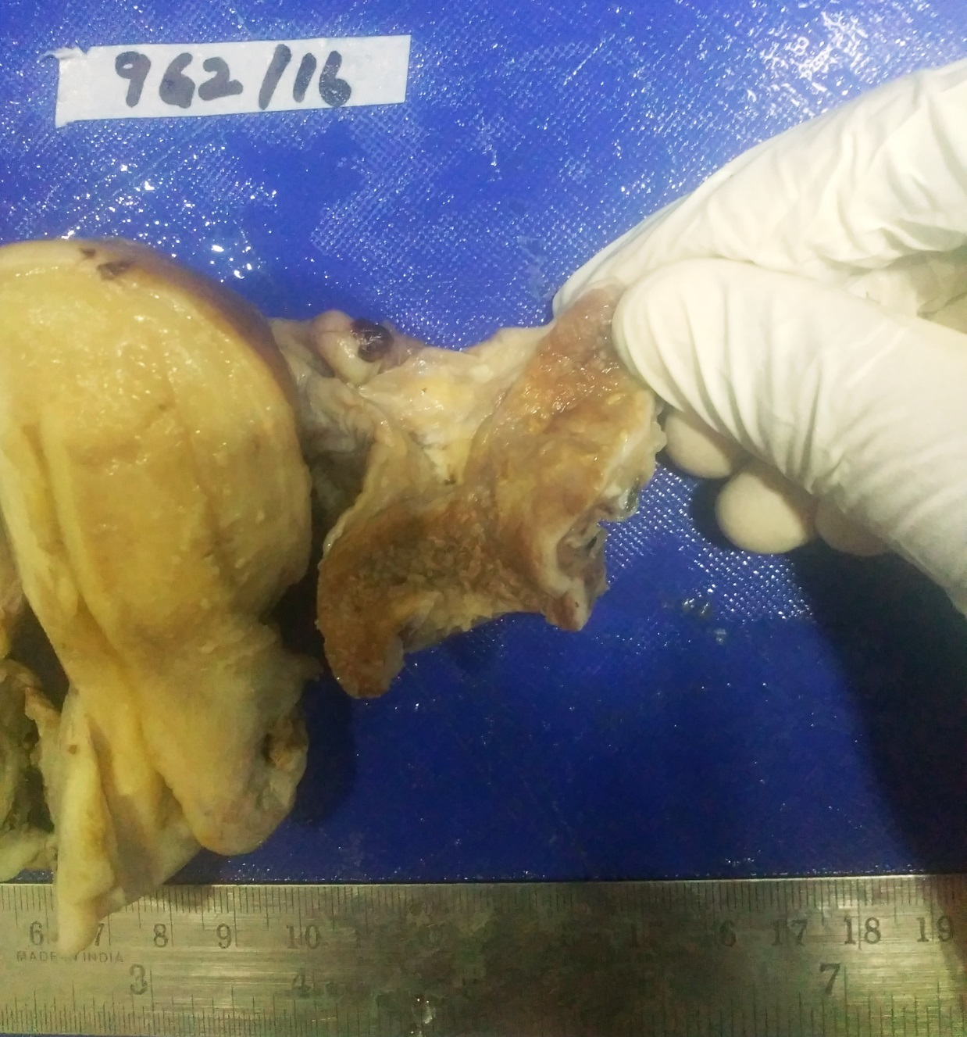
Figure:2 Ovary cut surface showing multiple papillary projections

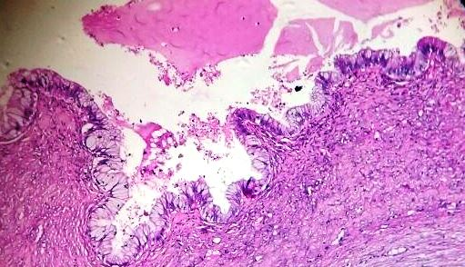
Figure 3:Mucinous cystadenocarcinoma 10x,H & E

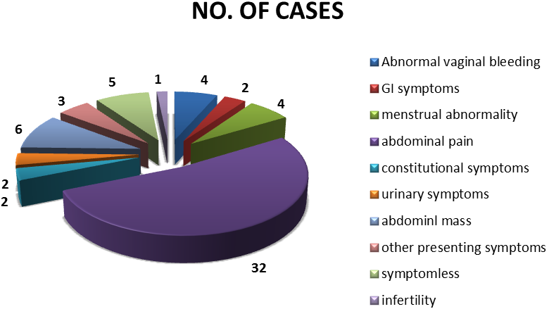
Figure 4: Clinical presentation of cases of ovarian tumors

TABLES:
Table 1. Different histological types of ovarian lesion
TYPE | NUMBER | PERCENTAGE
Surface epithelial tumor | 53 | 87%
Germ cell tumor | 4 | 6.5%
Sex cord stromal tumor | 4 | 6.5%
Others | - | -
Total | 61 | 100%

Table 2. Histological types of ovarian lesions.
Histologic type | Benign | Borderline | Malignant | Total
Serous | 34 | 0 | 3 | 37
Serous cystadenofibroma | 5 | 0 | 0 | 5
Fibrothecoma | 2 | 0 | 0 | 2
Borderline mucinous | 0 | 1 | 0 | 1
Mucinous | 7 | 0 | 1 | 8
Endometrioid | 0 | 0 | 1 | 1
Brenner | 1 | 0 | 0 | 1
Granulosa cell tumor | 0 | 0 | 1 | 1
Mature teratoma | 4 | 0 | 0 | 2
Immature teratoma | 0 | 0 | 1 | 1

Table 3. Laterality of ovarian tumors

Diagnosis | Unilateral | Bilateral | Total
Serous cystadenoma | 26 | - | 26
Mucinous cystadenoma | 4 | - | 4
Endometrioid | 1 | - | 1
Serous cystadenofibroma | 1 | 1 | 2
Serous cystadenocarcinoma | 1 | 2 | 3
Mucinous cystadenocarcinoma | 1 | - | 1
Brenner’s tumor | 1 | - | 1
Granulosa cell tumor | 1 | - | 1
Mature cystic teratoma | 2 | - | 2
TOTAL | 38 | 3 | 41

Table 4. Incidence benign and malignant ovarian lesions
Benign/malignant | Percentage
Benign | 87 %
Malignant | 11.4 %
Borderline | 1.6 %

Table 5. Age distribution of various histological types of ovarian lesions
Age (in years) | Surface epithelial tumors |  |  | Sex cord stromal tumors | Germ cell tumors |  | Total | Percentage
 | Benign | Borderline | Malignant |  | Benign | Malignant
<20 | 4 | 0 | 0 | 0 | 0 | 0 | 4 | 6.5%
21-30 | 8 | 0 | 1 | 0 | 1 | 1 | 11 | 18%
31-40 | 8 | 0 | 1 | 0 | 2 | 0 | 11 | 18%
41-50 | 13 | 1 | 0 | 2 | 0 | 0 | 16 | 26.2%
51-60 | 5 | 0 | 0 | 1 | 1 | 0 | 7 | 11.4%
>60 | 8 | 0 | 4 | 0 | 0 | 0 | 12 | 19.6%
TOTAL | 53 |  |  | 3 | 4 | 1 | 61 | 100%

Table 6: Clinical presentation of cases of ovarian tumors
Symptoms | Number of cases
Abdominal pain | 32
Symptomless | 5
Abdominal mass | 6
Other constitutional symptoms | 2
Gastrointestinal symptoms | 2
Urinary symptoms | 2
Menstrual abnormalities (including Abnormal uterine bleeding) | 8
Other presenting symptoms | 3
Infertility | 1
Total | 61

