Undifferentiated Subtype of Non-keratinizing Carcinoma of the Nasopharynx Metastasizing to the Breast: A Case Report and Literature Review
ABSTRACT
Nasopharyngeal carcinomas (NPCs) have a particularly high risk for aggressive clinical behavior. Metastatic tumors or secondary malignant neoplasms to the breast are uncommon. Breast metastasis of NPCs is very rare. We report a case of NPC in a 17-year-old female patient presenting with a mass in her left breast. The tumor consisted of an inflammatory infiltrate rich in lymphocytic or plasmacytic cells and composed of carcinoma cells having large, vesicular, round to oval nuclei with single, centrally located, eosinophilic nucleolus with eosinophilic cytoplasm. The epithelial tumor cells were strongly positive for pancytokeratin and CK19 and negative for CK7, CK20, progesterone, and estrogen receptors. NPCs are predominantly seen in adults with an average age of 50 years at diagnosis, and they are slightly more common in men than in women. The etiology of NPCs is generally multifactorial, such as genetic predisposition, Epstein-Barr virus infection, and environmental factors. A review of the literature on NPC yielded eight cases of metastasis to the breast. Excessive radical surgery is not suitable for metastatic tumors in the breasts of these patients, but isolated success has been obtained with a combination of local surgery and radiation therapy.
Key words: Breast, carcinoma, metastasis, nasopharyngeal carcinoma

Introduction
Metastatic tumors in the breast arise for the most part in malignant melanoma, lymphoma, lung cancer, and carcinoma of the ovary. Metastases from the head and neck region from malignant tumors are uncommon [1]. For nasopharyngeal carcinomas (NPCs), the relationship between race, geographical areas, and multifactorial etiology should be noted. Worldwide, NPC constitutes approximately 65,000 new cases per year and accounts for 38,000 cancer cases death annually. The vast majority of neoplasms in this category are non-keratinizing carcinomas, which itself are the most common subtype of undifferentiated carcinomas [2]. Occasionally, patients with NPCs have presented with lymphadenopathy, and the most frequent metastatic sites are retropharyngeal and level II lymph nodes [3]. Distant metastases occur most often to bone, lung, liver, and retroperitoneal lymph nodes [4]. To the best of our knowledge, only eight cases have been reported previously in the medical literature [1, 5, 6, 7, 8](Table 1). The clinicoradiological findings and pathological features of this unusual presentation are reported here.
Case report
A 17-year-old female arrived at the surgery department of a state hospital with non-specific, systemic symptoms, such as breast pain; a painless, palpable breast mass was detected. Breast ultrasonography and upper abdomen computed tomography (CT) imaging revealed the presence of a 7.8 cm × 4.8 cm (in diameter) solid mass in the left breast region, which was clinically considered as a tumor and was resected completely. We report a case; which was diagnosed in 2011 in a patient, he was diagnosed with stage I (T1N0M0) nasopharyngeal carcinoma (NPC) with tumour confined to nasopharynx.Magnetic resonance imaging was performed on the nasopharynx posterior wall and lateral walls, following an injection of intravenous contrast. T1a weighted signal due to post-contrast scans are performed; hypointense and T2a weighted signal due to hyperintense. The patient was diagnosed with NPC and developed a left breast mass (Fig.1A, B, C, D).The tumor measured 4 cm × 1 cm × 1 cm in diameter, and serial sections of the surgical specimen did not reveal tumor infiltration to the peripheral compartment. Its gross appearence was a soft, grayish-white tissue, which was a well-localized, well-demarcated, smooth mass. The cut surface of the tumor revealed ill-defined, solid areas that were focally prominent and gray with myxoid changes (Fig. 2). Microscopically, the tumor consisted of a prominent, chronic inflammatory infiltrate rich in dense lymphocytic or plasmacytic infiltrate with less eosinophilic background and composed of carcinoma cells having large, vesicular, round-to-oval nuclei with single, centrally located eosinophilic nucleoli with eosinophilic cytoplasm. Most of this tumor was composed of sheets of cohesive epithelial cells with only small foci lacking cohesive tumor cells. Immunohistochemically, the epithelial tumor cells were diffusely and strongly positive for pancytokeratin and CK19. The cells were focally positive for CK5/6 but negative for CK7, CK20, progesterone receptors, and estrogen receptors (Fig. 3A, B, C, D). Absence of in situ ductal or in situ lobular carcinoma.
Discussion
The incidence of breast involvement by other non-mammary malignancies is very rare (approximately 0.4% to 1.3%). The most common sources of metastases to breast are primary neoplasms from adverse effects of breast lymphoma or leukemia and malignant melanoma [9]. First described by Dawson (1936), metastases, the stomach signet ring cell carcinoma, is situated at the lymphatic channel in the breast. With these characteristics, the median interval to the development of a breast metastasis is approximately 2 years for cases with previously treated cancer. Metastatic disease, defined as a single lesion in the breast region, is seen in approximately 85% of cases [10]. It is more common in Southern Chinese and African populations, in which the annual incidence rises to 30–50 per 100,000 persons [11]and 23.3 and 8.9 cases per 100,000 persons per year for men and women, respectively [4]. The age distribution is similar in men and women; however, it occurs predominantly in males [2]. Although the etiology is multifactorial, including genetic predisposition and specific carcinogens, by far the most important known predisposing factor is infection with the Epstein-Barr virus (EBV) [11, 12]. In this section, we present a simplified version, taking into account the etiopathogenetic correlation of precursor EBV and the undifferentiated form of NPC (WHO type III) [13]. NPCs are most common in the region of the lateral wall of the nasopharynx with particular frequency in the fossa of Rosenmüller. Grossly, most lesions present as exophytic, but it is rarely ulcerated. Patients may be asymptomatic or may present with a mass in the posterior cervical triangle or superior jugular chain of nodes and sometimes present in the otitis media, epistaxis, and nasal obstruction [14]. NPCs are generally characterized by more aggressive clinical behavior; most present with a metastasis with extensive locoregional involvement and hematogenous or lymphatic spread [2]. Bones constitute the most common metastatic site (75%), followed by lung (46%), liver (38%), and retroperitoneal lymph nodes (10%) [4]. Previous studies demonstrate the mean age of breast metastases from undifferentiated NPCs is 42 years (25 to 51 years). In the present case, we present the first 17-year-old case of breast metastases from NPC to expand the medical database; there are no previously described reports of this in the literature. NPCs can be subdivided into three distinct groups: non-keratinizing carcinoma (the most common form), undifferentiated subtype (WHO III), and the condition called lymphoepitheliomas [15]. Histologically, the undifferentiated subtype is characterized by solid sheets and nests of the epithelial cells with cytoplasmic eosinophilia and round or oval vesicular nuclei and large, central, and prominent nucleoli with a dense, prominent lymphoplasmacytic infiltrate [16].

There are patterns of growth of NPC: Schmincke type is characterized by small clusters or aggregates and Regaud type also occurs in the large syncytial cells [17].The immunophenotype of NPC has the following characteristics: positive for EBER, pancytokeratin, CK5/6, 34βE12, CK8, CD56, CK13, CK19, p63, and p53, but usually negative for CK4, CK7, CK10, CK14, CK20, p16, and HPV [14]. The most specific markers of breast carcinoma are gross cystic disease fluid protein 15 (GCDFP-15). There is apparently a diagnostically useful difference in the immunoprofile of breast carcinoma in the sense that the former is usually positive for CK7, GATA3, ER, and GCDFP-15 and negative for CK20 [18]. In most instances, the differential diagnosis of the undifferentiated subtype of non-keratinizing carcinoma resembles a number of other small round cell neoplasms of the sinonasal tract, including neuroblastoma, lymphoma, rhabdomyosarcoma, melanoma, plasmacytoma, and other [15]poorly differentiated carcinoma in primary breast cancer [10].Radiotherapy for NPC, therefore, is the gold standard for treatment, and the 5-year survival rate in this series was 70% [11]. In contrast, the median survival for patients with metastatic tumors in the breast was approximately 10 months after the diagnosis of the metastases, and the patients ranged in survival from 0.4 to 192.7 months [10]. The prognosis of these metastatic tumors in the breast is substantially worse [7]. Primary treatment of metastatic tumors in the breast is radiation therapy and wide excision supplemented, if necessary, with therapy and/or combined axillary dissection. Mastectomy is not recommended as the therapy of choice [10]. The patient was treated with conventional radiotherapy as follows;who received radiotherapy to the head and neck region and during a follow-up appointment 20 months after the diagnosis of breast metastasis (Table 2). At the end of the 21-month follow-up period, the patient was disease-free and continuing to come in for routine physical examinations.

Conclusion
In conclusion, breast metastases are most frequently confused with benign lesions and primary breast cancer. Obviously, metastasis to the breast requires a multidisciplinary approach with close cooperation and dialogue among the clinician, oncologist, radiologist, and pathologist. There should be careful comparison of suspicious foci with the cytologic or radiologic pattern in the initial diagnostic core needle biopsy. Therefore, patients with metastatic breast lesions may have been treated by unnecessary excessive radical surgery.
Conflict of interest
No financial competing interests.
Funding source
None.

References
[1] Driss M, Abid L, Mrad K, Dhouib R, Charfi L, Bouzaein A, Ben Romdhane K: Breast metastases from undifferentiated nasopharyngeal carcinoma. Pathologica 2007;99:428-30 PMID: 18416334
[2] Chan JKC, Pilch BZ, Kuo TT, Wenig BM, Lee AWM: Tumours of the nasopharynx. In Barnes L, Eveson JW, Reichart P, Sidransky D. (Eds): Pathology and Genetics of Head and Neck Tumours, Lyon, IARC Press, 2005;81-106
[3] Ho FC, Tham IW, Earnest A, Lee KM, Lu JJ: Patterns of regional lymph node metastasis of nasopharyngeal carcinoma: a meta-analysis of clinical evidence. BMC Cancer 2012;21:12:98 PMID: 22433671, doi: 10.1186/1471-2407-12-98.
[4] Huang CJ, Leung SW, Lian SL, Wang CJ, Fang FM, Ho YH: Patterns of distant metastases in nasopharyngeal carcinoma. Kaohsiung J Med Sci 1996;12:229-34 PMID: 8683644
[5] Leach BI, Sun B, Petrovic L, Liu SV: Breast metastasis from nasopharyngeal carcinoma: A case report and review of the literature. Oncol Lett 2013;5:1859-1861 PMID: 23833656, DOI: 10.3892/ol.2013.1303
[6] Yeh CN, Lin CH, Chen MF: Clinical and ultrasonographic characteristics of breast metastases from extramammary malignancies. Am Surg 2004;70:287-90 PMID: 15098776
[7] Vaishnav KU, Pandhi S, Shah TS, Chaudhry A.Nasopharynx carcinoma: a rare primary for bilateral breast metastasis.BMJ Case Rep. 2012 Jul 9;2012. pii: bcr0320126083. doi: 10.1136/bcr.03.2012.6083.
[8] Liang N, Xie J, Liu F, Xu D, Yu X, Tian Y, Song M, Zhang J. Male breast metastases from nasopharyngeal carcinoma: A case report and literature review. Oncol Lett. 2014;7:1586-1588. Epub 2014 Feb 20.
[9] Maounis N, Chorti M, Legaki S, Ellina E, Emmanouilidou A, Demonakou M, Tsiafaki X: Metastasis to the breast from an adenocarcinoma of the lung with extensive micropapillary component: a case report and review of the literature. Diagn Pathol 2010;17:5:82 PMID: 21167048, doi: 10.1186/1746-1596-5-82.
[10] Hoda SA: Metastases in the Breast from Nonmammary Malignant Neoplasms. In Rosen PP (Ed): Rosen’s Breast Pathology, 4nd ed., Lippincott Williams&Wilkins, Philadelphia, 2014;937-956
[11] Sidler D, Thum P, Winterhalder R, Huber G, Haerle SK: Undifferentiated carcinoma of nasopharyngeal type (UCNT): a Swiss single-institutional experience during 1990-2005. Swiss Med Wkly 2010;140:273-9 PMID: 19950040, doi: smw-12844.
[12] Chu EA, Wu JM, Tunkel DE, Ishman SL: Nasopharyngeal carcinoma: the role of the Epstein-Barr virus. Medscape J Med 2008, 10:165 PMID: 18769688
[13] Gullo C, Low WK, Teoh G: Association of Epstein-Barr virus with nasopharyngeal carcinoma and current status of development of cancer-derived cell lines. Ann Acad Med Singapore 2008;37:769-77 PMID: 18989494
[14] Thompson LD: Update on nasopharyngeal carcinoma. Head Neck Pathol 2007;1:81-6 PMID: 20614287, doi: 10.1007/s12105-007-0012-7
[15] Barnes L: Diseases of the Nasal Cavity, Paranasal Sinuses, and Nasopharynx. In Barnes (Ed): Surgical Pathology of the Head and Neck, New York, Informa Healthcare, 2008;343-423
[16] Wakely PE: Nasopharengeal Carcinoma, Nonkeratinizing Undifferentiated Type. In Suster S (Ed): Head and Neck Pathology, New York, Demos Medical, 2011;17-18
[17] Regauer S: Nasopharynx and Waldeyer’s Ring. In Cardesa A, Slootweg PJ (Eds.): Pathology of the Head and Neck, New York , Springer, 2006;171-190
[18] Bhargava R, Dabbs DJ: Immunohistology of the Breast. In David J. Dabbs. (Ed): Diagnostic Immunohistochemistry Theranostic and Genomic Applications, Philadelphia, Elsevier Saunders, 2014;710-761
[19] Que J, Chien-Tai H, Shih-Sung C, Li-Ching L, Kue-Li L: Breast Metastases from Nasopharyngeal Carcinoma: a case report and literature review. Chin J Radiol 2003;28:323-327

Figure Legends
Figure 1: Magnetic resonance imaging (MRI). (A, B) Preoperative MRI.A)Axial post-contrast T1-weighted MRI showing a nasopharyngeal carcinoma B) Sagittal T1 weighted MRI. C,D; postoperative MRI and postoperative local radiotherapy. C, D) Axial post-contrast T1-weighted MRI.
Figure 2: Gross appearance of breast specimen.
Fig. 3. (A)Low-power views of the corresponding microscopic specimen. Nasopharyngeal carcinoma (left) and benign duct/tubule of breast (right) (Hematoxylin and Eosin, 40× objective).
(B)Undifferentiated nasopharyngeal carcinoma composed cells growth in a syncytial pattern and dense prominent lymphoplasmacytic infiltrate(Hematoxylin and Eosin, 40× objective).
(C)Undifferentiated nasopharyngeal carcinoma composed of tumor cells of oval to round large vesicular nuclei, with eosinophilic nucleolus (Hematoxylin and Eosin, 200× objective).
(D)Immunohistochemically positive for pancytokeratin (100×objective).

Table 1 Data of the published cases of NPC metastasis to the breast.

References | Year | Age(years) | Gender
Sham et al. | 1986 | 39 | F
Sham et al | 1987 | 51 | F
Driss et al. | 1999 | 25 | F
Que et al. | 2003 | 41 | F
Yeh et al. | 2004 | 44 | F
Vaishnav | 2012 |  | F
Liang et al. | 2013 | 49 | M
Leach et al. | 2013 | 49 | F
This case | 2013 | 17 | F

Table 2 Chronological history (treatment and diagnosis) of the this case.

Teratment or diagnosis processes | Diagnosis and treatment | Date | Radiology | Stage
The initial presentation | NPC | 11.10.2011 | Magnetic resonance imaging (MRI) | Stage I (T1N0M0)
Treatment:conventional radiotherapy | Head and neck region:  -Radiotherapy: 43 days, total dose 70 Gy.  -Chemotherapy:  Cisplatin 178 mg/first day (100mg/m2),  5 Fluorouracil 1780 mg/5 day (1000 mg/ m2) every 21 days.
Breast metastasis | NPC | 19.06.2013 | Computed Tomography (CT)
Preoperative
-Radiotherapy:
15 days, total dose 70 Gy
Surgery:Pathologic diagnosis | Undifferentiated Subtype of Non-keratinizing Carcinoma of the Nasopharynx | 14.08.2013 |  | Stage IVC (T1N0M1)
After surgery | Local excision, Postop.  -Chemotherapy:  Docetaxel 100 mg/ one day (60mg/m2),  5 Fluorouracil 2500 mg/2 day (1000 mg/m2),  Carboplatin (AUC 5), four cycles, every 21 days.
At the end of the 21-month follow-up period | The patient was disease-free and continuing to come in for routine physical examinations. | 14.05.2015 | MRI, CT

Figure 1
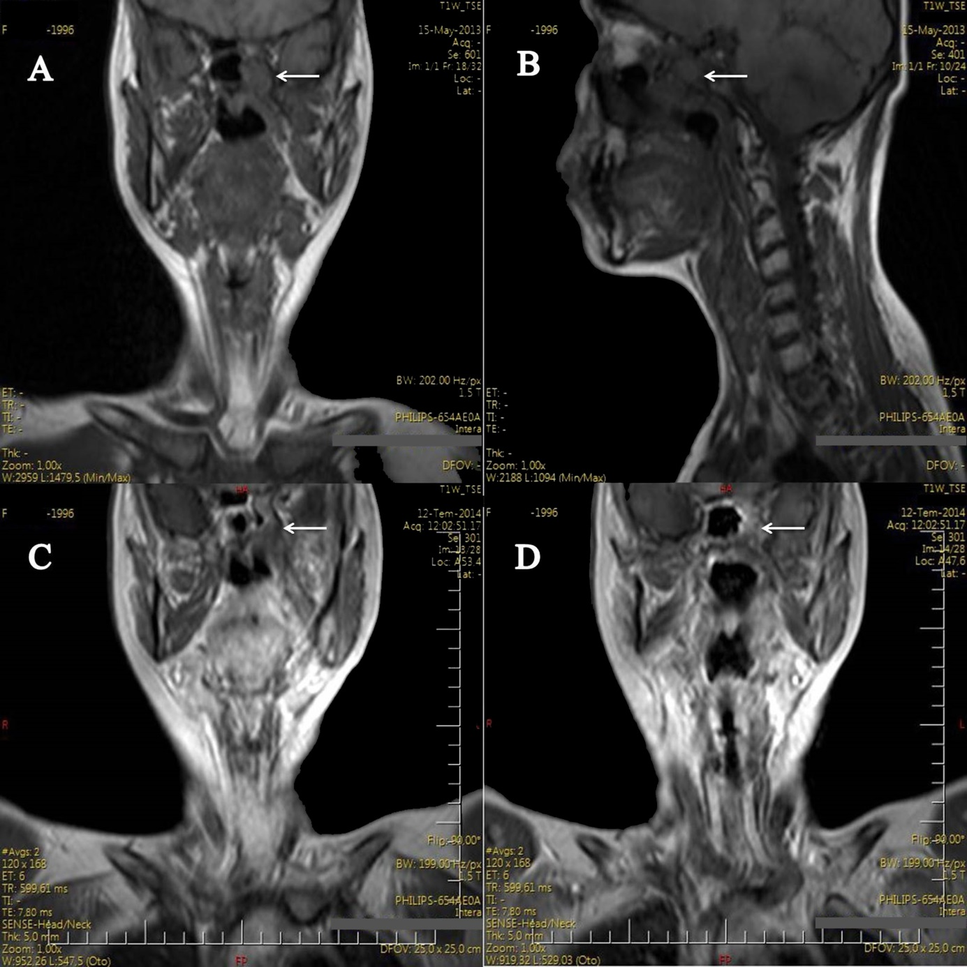

Figure 2
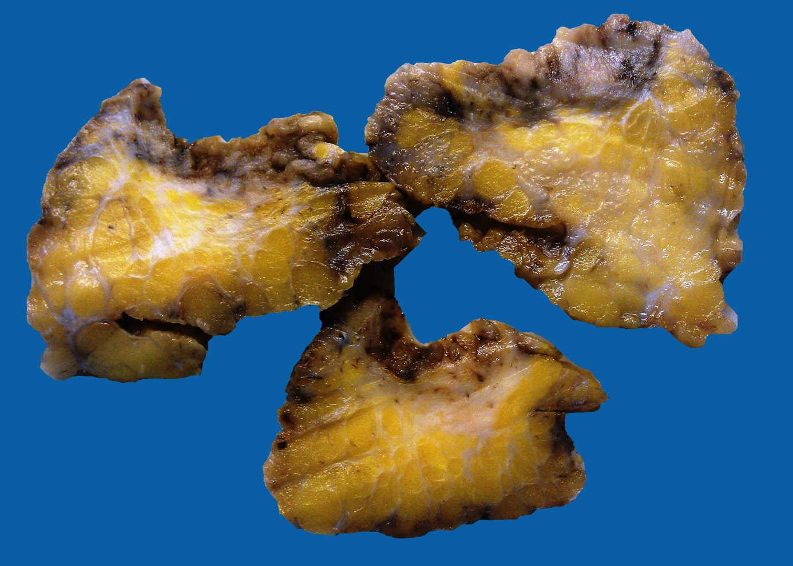

Figure 3A
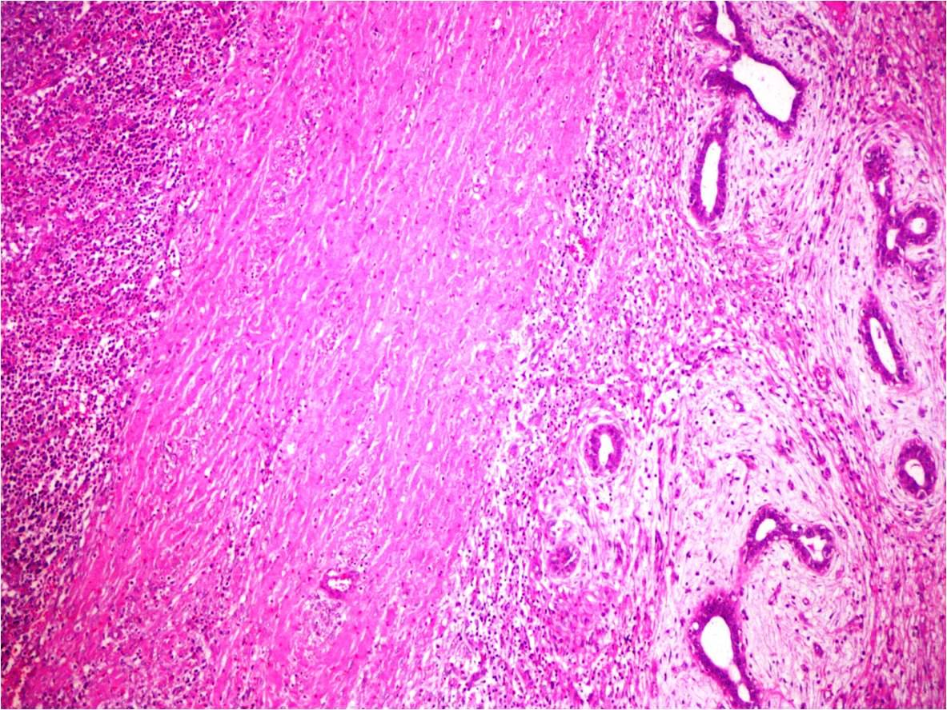

Figure 3B
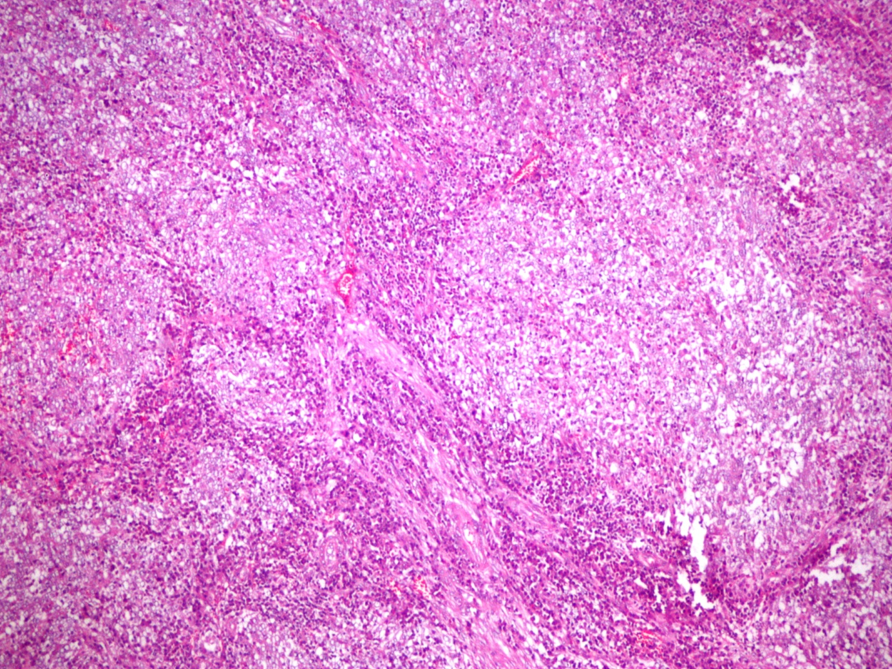

Figure 3C
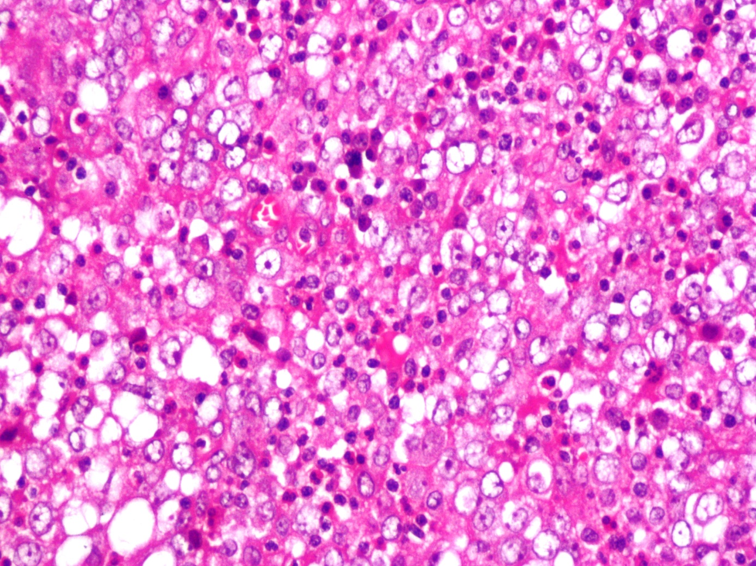

Figure 3D
