Premalignant Lesions Of Prostate And Its Association With Nodular Hyperplasia And Carcinoma Of Prostate - A Histomorphological Study

Introduction
The incidence of prostatic carcinoma increases with age, and it ranks second to lung cancer in terms of incidence and mortality risk. ^{[1]}
Significant advances have occurred in identifying the putative premalignant lesions of prostate. Application of modern technology such as immunochemistry, flow cytometry, fluorescent insitu hybridization (FISH) has yielded much valuable information in the study of premalignant and malignant lesions of prostate.
The concept of tumour development through a multistep via premalignant lesions has been well documented in the number of organs including uterus, cervix, endometrial, gastrointestinal and respiratory tract ^{[2]} which is similarly seen in prostate.
Orteil gave the first description of premalignant changes in the prostate. The premalignant lesions of prostate include prostatic intraepithelial neoplasia (PIN) and atypical adenomatous hyperplasia (AAH) ^{[3]} and recently, the new lesion added to the list of premalignant lesion is proliferative inflammatory atrophy (PIA). ^{[4]}
In clinical practice, AAH, HGPIN and PIA remains undetected as most of these lesions does not reveal any abnormality on clinical (digital rectal examination), biochemical (PSA level analysis and radiological (trans rectal ultrasound) evaluation.^{[5]} Hence, histopathology remains the gold standard for diagnosis of these putative precursor lesions of prostatic carcinoma. Identification of these lesions of prostate help in early detection of carcinoma and guide the urologist for appropriate management of the patient.
Hence, the present study was undertaken to identify the premalignant lesions and its association with benign and malignant lesions of prostate and also to know the rate of prostatic carcinoma diagnosed on repeat biopsies of the premalignant lesions of the prostate.
Materials and Methods
The descriptive study was conducted for a period of six years from 2009-2015. During this period, a total of 1,023 cases were studied. The material for the present study consisted of transurethral resection of prostate (TURP), needle biopsies (NB) and prostatectomy specimens collected from patients attending the outpatient department of urology. Brief clinical data was noted from the case records, which included age, presenting symptoms, digital rectal examination (DRE) findings, serum prostatic specific antigen (PSA) levels and clinical diagnosis. All the prostatic biopsy specimens were submitted to the department of pathology.
Eligibility criteria adopted in our study.
- Inclusion criteria
All types of prostatic specimens like transurethral resection of prostate (TURP), needle biopsies (NB) and prostatectomy specimens were included.
- Exclusion Criteria
Inadequate biopsies and poorly preserved prostatic specimens were excluded.

All the prostatic specimens were subjected to detailed gross examination fixed in 10% neutral buffered formalin and processed. Three sets of section of 3-4microns thick were cut. One set of slide was stained with routine haematoxylin and eosin (Hand E) stain for histopathological diagnosis. The second section (3µ thick) was stained with silver nitrate to visualise the Nucleolar Organizer regions (NORs) using Howel’s and Black rapid 1-step method.^{[6]} Sections were examined under light microscopy using oil immersion lens (X100). AgNOR appears as black dots/ purple-black following toning against light blue background. The third section was subjected to specific red cell adherence test (SRCAT) as per the procedure mentioned by Kovarik S and Davidson. ^{[7]}
Statistical analysis:
The collected data was tabulated, analyzed and subjected for statistical analysis using SPSS 17.0 Results are presented as Mean ± SD and range for quantitative data and number and percentages for qualitative data. Depending upon the nature of data Group-wise comparisons were made either by student t- test, Fisher’s test or Mann- Whitney test. P value of 0.05 or less was considered for statistical significance.

Results
In the present study a total of 1,023 prostatic specimens were received to the department of pathology accounting for 5.1% of total specimens received. Out of 1,023 specimens, 539 cases (52.68% ) were benign, 385 cases (37.63%) were premalignant and 99 cases (9.67% ) were malignant (table 1). Majority of cases of premalignant lesions were in the age range of 61-70 years (48.31%) followed by 71-80 years (23.11%) and 51-60 years (14.8%) of age group
(graph 1). Among the nature of specimens the premalignant lesions were common in needle biopsies (49.1%) followed by TURP (46.5%) and prostatectomy specimen (4.4%). Details of histomorphological features of premalignant lesions of prostate and its association with benign and malignant lesions are given in table 2 and 3.
Discussion
Prostatic carcinoma is one of the most prevalent types of carcinoma in men. The early diagnosis of carcinoma can be done by early detection of focus of premalignant lesion of prostate. Significant advances have been achieved in the diagnosis and treatment of prostate carcinoma with the introduction of PSA and prostate biopsy techniques. However, the histological diagnosis of premalignant lesions in biopsy specimens remains a challenge for the pathologists. The lack of availability of immunohistochemical staining, that differentiate the benign, premalignant and malignant acini, poor diagnostic significance of the absence of basal cells in some cases complicate the diagnosis of premalignant and malignant lesions of prostate.
Prostatic intraepithelial neoplasia (PIN) is a neoplastic transformation of lining epithelium of prostatic ducts and acini. The process is confined within the epithelium. ^{[5]}
The term PIN was introduced in 1987 by Bostick. It is divided into two grades – low grade PIN (LGPIN) and high grade PIN (HGPIN) based on the severity of the following alteration such as cell crowding, stratification, nuclear enlargement, pleomorphism, chromatin pattern and nucleolar appearance.^{[8]} The prevalence of LGPIN varies considerably in different studies probably because of histological diagnosis of LGPIN shows subjective variation and many studies do not report LGPIN. ^{[9]}
Histologically HGPIN is characterized by architectural and cytological alteration with large nuclear size, an increased chromatin content which is irregularly distributed with prominent nucleoli. The basal cell layer show frequent disruptions in the HGPIN (Figure 1, 2, 3).

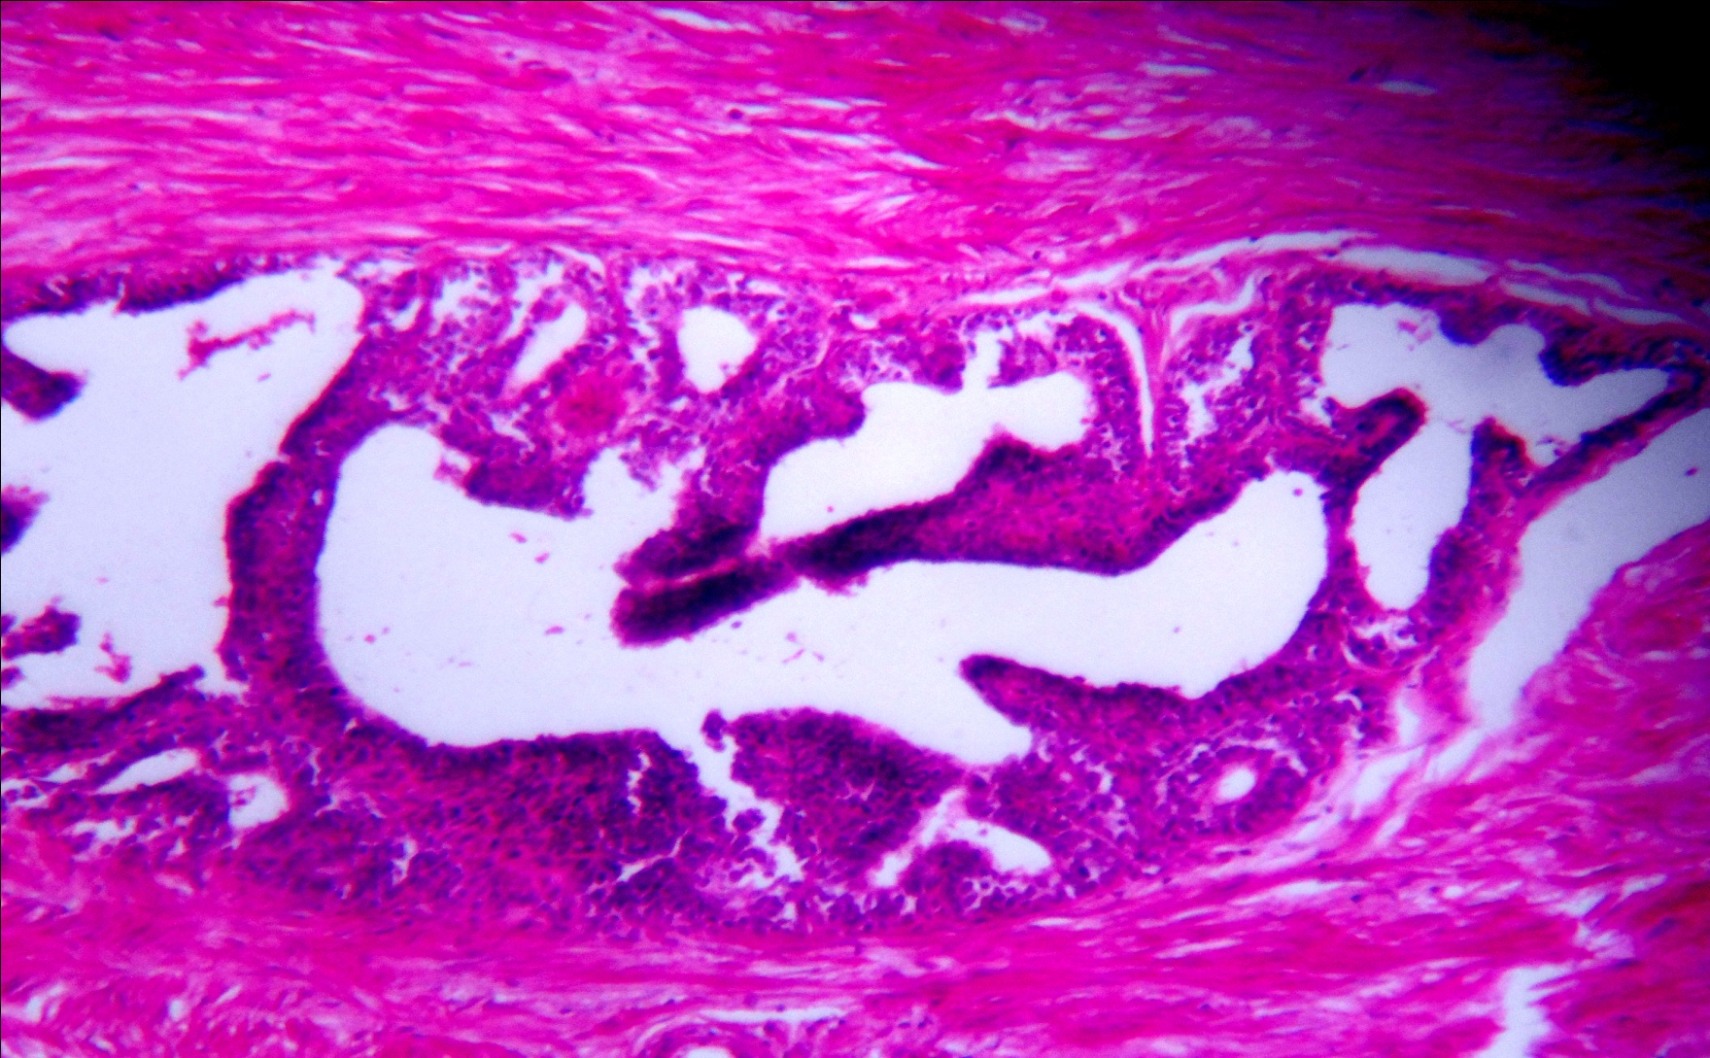
Figure 1.HGPIN with micropapillary pattern showing epithelial cell stratification, crowding with enlarged nucleus and prominent nucleoli in case of nodular hyperplasia. (H&E, x400) 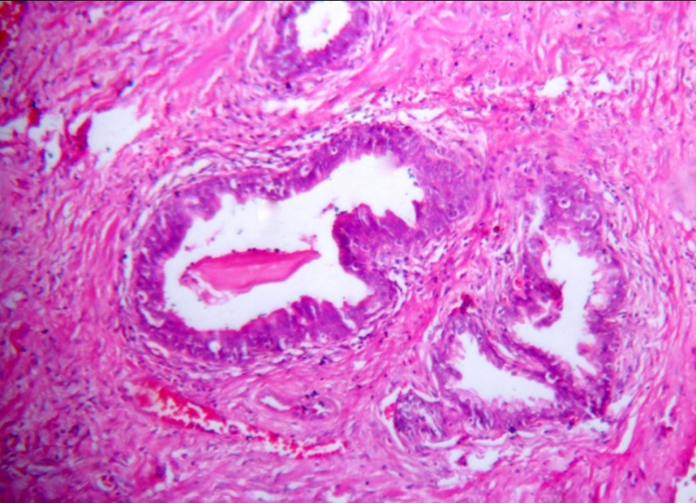
Figure 2. HGPIN with tufting pattern showing epithelial cell stratification, crowding with enlarged nucleus and prominent nucleoli in case of nodular hyperplasia. (H&E, x400)

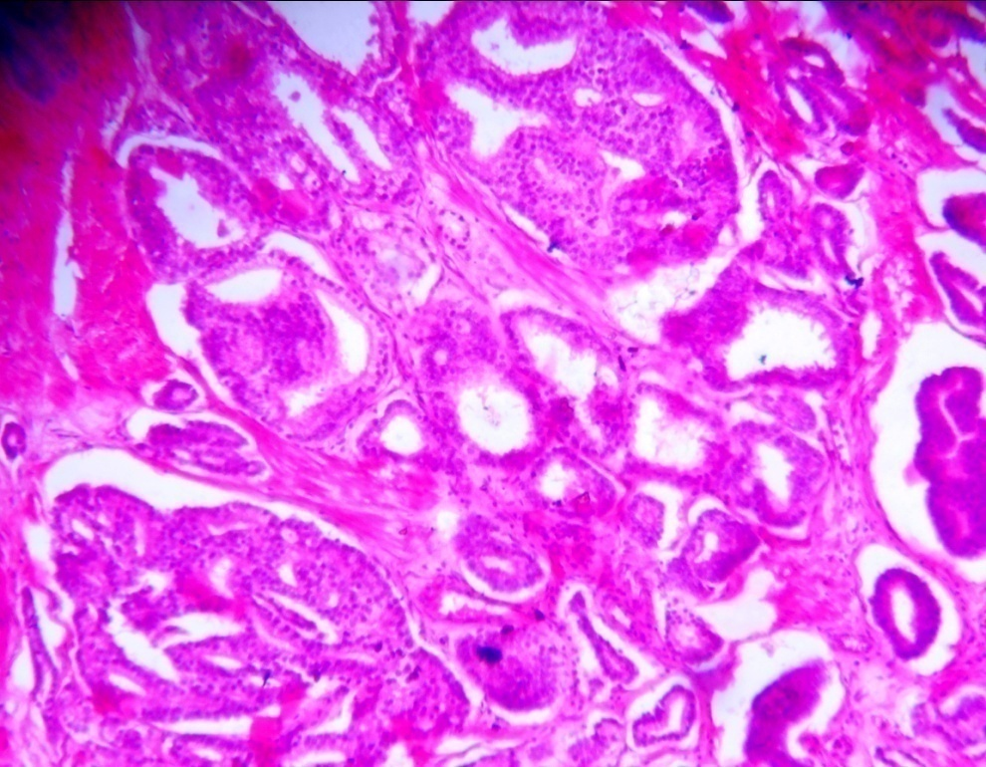
Figure 3. HGPIN showing cribriform pattern of glands with luminal bridging
and adjacent area of infiltrating carcinoma (H&E, x400)

Morphological patterns of PIN include micropapillary, cribriform and flat and tufting pattern at the architectural level.^{[10]} The histological variants of PIN are signet-ring, mucinous variant, foamy variant, inverted and small cell neuroendocrine variant at the cytoplasm level.^{[5]} Among these, the cribriform pattern is the most difficult to distinguish from invasive tumours, particularly in biopsy specimens.^{[10]}
The differential diagnosis of HGPIN includes both benign and malignant conditions. The benign conditions such as atypia induced by inflammation, infarction, radiation, transitional cell metaplasia, basal cell hyperplasia, clear cell cribriform hyperplasia. The malignant lesions include transitional cell carcinoma of prostatic ducts and acini and cribriform acinar and ductal prostatic carcinoma. Hence one should rule out all the possibilities before the diagnosis of HGPIN.
Recent literatures reveal, in adjunct to histomorphological features the newer techniques like histochemistry, immunohistochemistry (IHC), flow cytometry,, FISH and static image analysis help in understanding the molecular pathology of PIN. On IHC of 34Ebeta12, P63, CK5/6 and AMACR (P450S) show disrupted staining in HGPIN. Upregulation of EGF, overexpression of MAP kinases, bcl-2 and matrix metalloprotinases with down regulation of E- cadherin have also been noted in PIN. ^{[11]}
HGPIN has a high predictive value as a marker for moderately to poorly differentiated adenocarcinoma of prostate. Hence, its identification in biopsy specimen warrants repeat biopsy for concurrent/subsequent carcinoma.^{[11]} Current standards recommend that the patient with isolated HGPIN be re-biopsied in 0-6 months, irrespective of the serum PSA levels and DRE findings. The re-biopsy technique should entail at least systematic re-biopsy of the entire gland. Since, HGPIN is a general risk factor for carcinoma throughout the gland. These patients should be enrolled into clinical trials with chemopreventive agents.^{[5]} Hence, on detection of HGPIN, patient therapeutically should be started on androgen deprivation therapy (ADT), hormonal therapy and radiotherapy.^{[11]} The dysplastic prostatic epithelium is hormonal dependent and ADT reduces proliferation and enhances apoptosis.
In the present study a total of 276 cases of HGPIN out of 385 accounting for 71.6% of premalignant lesions of prostate. Out of 276 cases, 46 cases (16.6%) were associated with benign lesions and 230 cases (83.3%) were associated with malignant lesions of prostate. In 46 cases of isolated HGPIN associated with benign lesions were started on ADT therapy and these cases were followed up over a period of six months by repeated systematic re-biopsy of entire gland. Only 20 cases out of 46 developed adenocarcinoma accounting for 42.85% as compared to 35% of Davidson et al ^{[12]} study. The rest 16 cases responded to ADT therapy and did not develop carcinoma on re-biopsy technique during their follow-up period of 6 months.
In our study there is increase in the percentage of cancer detection rate in HGPIN cases could be attributed to the technique of 12-core needle biopsy (NB) used in the study and also due to frequent camps which were freely carried out to collect the samples in our urology institute. The 12- core NB helps to determine the foci of prostatic carcinoma by obtaining a sufficient amount of samples at the true location without increasing the morbidity. The 12-core needle biopsy (NB) involves transrectal ultrasound evaluated prostate volume and guiding the biopsies to the 12 following areas: right and left apex, right and left mid prostate, right and left base, right and left transition zone, 1 and 2 right mid-lateral and 1 and 2 left mid-lateral, unlike traditional sextant biopsy which samples only six cores. ^{[13]} Advantages of 12- core NB over traditional sextant biopsy are 1. It involves the transition zone biopsies from which additional cancers are detected. 2. It allows screening of large number cores from the entire gland. ^{[5]} 3. It helps in staging the tumour, predicting extra capsular extensions and tumour volume which are considered as prognostic factors. ^{[13]} 4. It helps in sampling high number of cores in previously determined site and adds prognostic information and help in defining the tumour biological behavior. We have also observed in our study that the quantity of cores involved with PIN is directly proportional to the occurrence of carcinoma. Hence, it is essential to highlight in the reports by the pathologist, the percentage of core involved by HGPIN for prognostic value. Literatures have also contributed, that the incidence of 30.2% if only ½ cores showed PIN, 40% with three cores and 75% with > three cores involvement by HGPIN. ^{[10]} The malignancy does not occur on subsequent first two follow-up biopsies from PIN diagnosed patients and then the cancer is unlikely to develop later. ^{[10]}

In our study, the diagnosis of HGPIN was made in combination, with histomorphological characters, alcian blue special stain and with the use of proliferative marker (AgNOR). The diagnosed HGPIN on histomorphology could not be further evaluated on IHC and flow cytometry due to poor economic constraint of patients.
In our study HGPIN was common in needle biopsy specimens accounting for 63.3 % of cases. The rise in prevalence of HGPIN in needle biopsies may probably be due to its distribution in the peripheral zone. ^{[14]}
The other putative premalignant prostatic lesion described by McNeal is atypical adenomatous hyperplasia (AAH). ^{[15]} It represents an architectural alteration with cytological unremarkable glands ^{[16]} (figure 4).
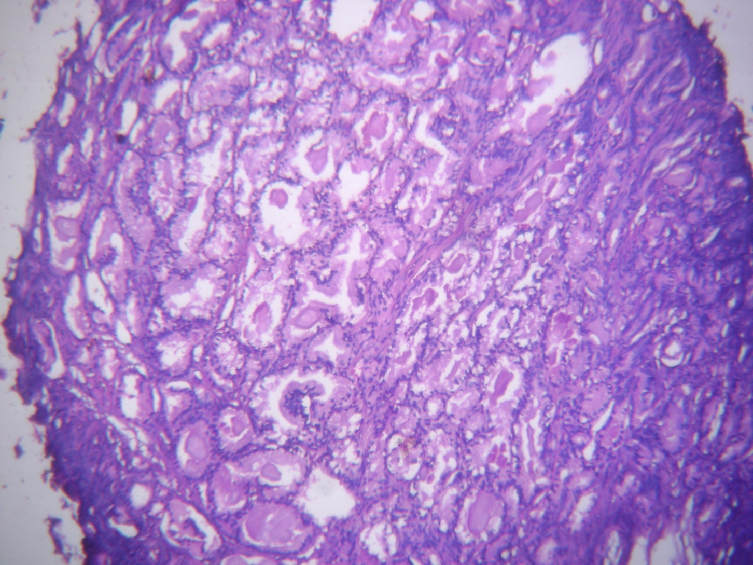
Figure 4. Atypical adenomatous hyperplasia (AAH) showing circumscribed cluster of glands in case of nodular hyperplasia (H&E, x100)

In most of the cases the AAH is an incidental finding in TURP and prostatectomy. AAH is located in the transition zone of the prostate in intimate association with BPH.^{[17]} Microscopically AAH is characterized by partially circumscribed with pushing borders consisting of varying sizes of small glands which are closely packed and separated. The glands are lined by cuboidal- low columnar cells with moderate – abundant, clear- eosinophilic cytoplasm. The basal cells are usually recognized focally. The luminal borders are irregular in contrast to rigid borders of carcinomatous glands. The nuclei are round-oval, enlarged with uniform fine chromatin with inconspicuous nucleoli.^{[18]}
AAH is difficult to distinguish from low-grade prostatic adenocarcinoma (Gleason pattern 1+2). Because both are located in the transition zone and show small acinar proliferation and intraluminal crystalloids. The two distinguishing features of AAH from carcinoma are lack of cytological atypia and presence of patchy basal cells can be made out by the use of immunostains like HMWCK (CK903/34betaE12) or P63. In contrast, prostatic adenocarcinoma shows nuclear atypia, lack of basal cells and rarely expresses HMCK.
AAH is considered to be a precursor of well- differentiated transition zone carcinoma. ^{[19]} It has been reported that the cancer detection rate varies between 21% and 51% on the second biopsy in patients with AAH. ^{[20]}
In our study AAH constituted 51 cases out of 385 premalignant lesions of prostate accounting for 13.2% of the cases. It is commonly detected in the TURP specimens (89.9%). Around 47 cases (92.1%) showed association with benign lesions as compared to 4 cases (7.8%) association with malignant lesions. AAH shows increased association with benign lesions and TURP specimens could be probably attributed to the surgical technique of TURP carried out for BPH. TURP technique involves resection of the central zone of the prostate where BPH and AAH are common.^{[3]} Rekhi B et al study revealed AAH in 20.6% of the cases of nodular hyperplasia and 2.6% cases of the adenocarcinoma. In our study higher percentage might be possibly due to large sample size of the benign cases.
During the follow-up period of repeated systematic re-biopsies only one case out of 51 cases developed well differentiated transition zone carcinoma accounting for 1.96% of the AAH cases. Patient underwent cystoprostectomy and follow-up period; showed no recurrence till the date of review of the case.
The next putative premalignant lesion is PIA. It was first proposed by De- Marzo et al.^{[21]} It designates focal simple/ post atrophic hyperplasia in association with inflammation.
PIA represents precursor lesion to HGPIN and therefore, prostatic adenocarcinoma. ^{[21- 25]} PIA histopathologically is characterized by closely packed small acini lined by atrophic epithelium having scanty cytoplasm with crowding of nuclei. Stroma shows inflammation with changes of elastosis and fibrosis. ^{[21]} (Figure 5).

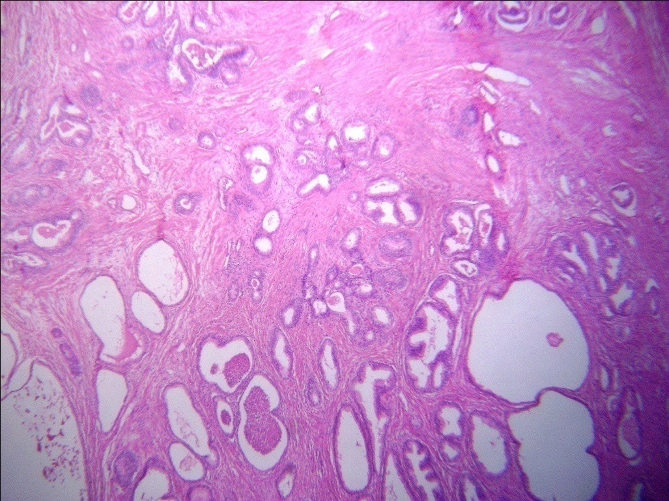

Figure 5. Proliferative inflammatory atrophy (PIA) showing areas of closely packed small acini lined by atrophic epithelium with stroma showing areas of fibrosis, elastosis and inflammation (H&E, x100)

Literature has revealed around 10.4 % of the cases of PIA on repeated systematic sextant re-biopsy show adenocarcinoma.^{[26]}
In our study 58 cases of PIA out of 385 premalignant lesions were found constituting15.1% of premalignant lesions of prostate. Our study revealed PIA common in needle biopsy specimens and shows increased association with malignant lesions accounting for 67.2% of the cases.The increased percentage may probably be due to the occurrence of PIA in the peripheral zone and hence, there is increase in the needle biopsy specimens which is used for detection of prostatic carcinoma. During the follow-up period of re-biopsies a total of five cases out of 58 developed adenocarcinoma of prostate accounting for 8.62% of the cases the decreased percentage in the present study is due to small sample size in our study.
Conclusion
As most of the premalignant lesions of prostate are not diagnosed clinically, histopathology remains the gold standard in the diagnosis of premalignant lesions of prostate. HGPIN and PIA showed strong association with malignant lesions and AAH showed weaker association. Hence, the focus of HGPIN, PIA and AAH should be highlighted by the pathologist and advised for close clinical follow-up with subsequent repeated re-biopsies which help in early dectection and management of the patient.
References

1. Polat K, Tüzel E, Aktepe F, Akdoğan B, Güler C, Uzun İ. Investigation of the incidence of latent prostate cancer and high-grade prostatic intraepithelial neoplasia in an autopsy series
of Turkish males. Turkish Journal of Urology 2009;35:96-100.

2. Del Regato JA, Sput HJ, Cox JD. Pathology of cancer. In: Harsh Berger SE, Kasper R, editors. Cancer diagnosis, treatment and prognosis. St Louis: Mosby 1985. p. 27-8.

3. Rekhi B, Jaswal TS, Arora B. Premalignant Lesions of Prostate and their
Association with Nodular Hyperplasia and Carcinoma Prostate. Indian Journal of Cancer 2000 ; 41:60 – 5.
- Athanase Billis. Prostatic Atrophy. Clinicopathological Significance. Int Braz J Urol 2010; 36: 401- 9.
- Sakr AW, Montironi R, Epstein IJ, Rubin AM, Demarzo MA, Humphrey AP, et al.
Prostatic intraepithelial neoplasia. In: Eble NJ, Sauter G, Epstein IJ, Sesterhenn AI
editors. Pathologyand genetics tumors of the urinary system and male genital
organs Lyon: IARC Press (World Health Organization. Classification of tumors
2004; 6: p.193-8.

6. Howel WM and Black DA.Controlled silver staining of nucleolus organizer regions
with a protective colloidal developer: a 1- step method. Experientia 1980;15;
36:1014-5
7. Kovarik S, Davidsohn I, Stejskal: ABO antigens in cancer. Detection with Mixed cell agglutination reaction. Arch Pathol 1968; 86:12-21.
8. Bostwick GD, Sakr W. Prostatic intraepithelial neoplasia. In: Foster SC, Bostwick
GD editors. Pathology of the prostate. Philadelphia: W.B. Saunders (Major
problems in pathology) 1998 ;( 34):p.95-114.
9. Gaudin BP, Epstein IJ. Adenosis of the prostate: Histologic features in needle
biopsy specimens. Am J Surg Pathol 1995; 9:737-47.
10. Rosai J. Male reproductive system. In: Rosai & Ackerman’s. Surgical Pathology.
9^{t h} ed. Vol.1, Missouri: Mosby. 2004. p.1361-1412.
11. Rodolfo M, Roberta M, Ferran A, Antonio L. Morphological identification of the patterns of prostatic intraepithelial neoplasia and their importance. J Clin Pathol 2000; 53: 655-65.
12. Davidson D, Bostwick DG, Qian J, Sioky M, Rudders R, Stilamant M. Prostatic intraepithelial neoplasia is predictive of adenocarcinoma. J Urol 1995;154:1295-9.
13. Paulo E. F, M. Tobias-Machado, Marcelo A. P, Lucilla H.S, Eric R. W. Twelve Core Prostate Biopsy Versus Six Systematic Sextant Biopsies. Braz J Urol 2002;28:207-13.

14. Haggman JM, Macoska AJ, Wojno JK, Oesterling EJ. The relationship between
prostatic intraepithelial neoplasia and prostate cancer: Critical issues. J Urol 1997;
158:12-22.
15. Mc Neal JE. Morphogenesis of prostatic carcinoma. Cancer 1985;1659-66.
16. Rosai J. Male reproductive system. In: Rosai J, editor. Ackerman’s Surgical pathology. 8th Ed. Missouri: Mosby-year book Inc 1996. p. 21-56.
17. Bostick DG, Qian J: Atypical adenomatous hyperplasia of the prostate. Relationship with carcinoma in 217 whole-mount radical prostatecctomies. Am J Surg Pathol 1995;19: 506-18.
18. Henry B.A and Anil. V.P. Atypical adenomatous hyperplasia (adenosis) of the prostate: a case report with review of the literature. Diagnostic pathology 2008;3:34.
19. Mettlin C, Jones GW, Murphy GP. Trends in prostate cancer in the United States, 1974-1990: Observations from the patient care evaluation studies of the American college of surgeons commission on cancer. CA Cancer J Clin 1993;43:83-91.
20. Orhan Koca, Selahattin Çalışkan, Metin İshak Öztürk, Mustafa Güneş, M. Ihsan Karaman.
Significance of Atypical Small Acinar Proliferation and High-Grade Prostatic Intraepithelial Neoplasia in Prostate Biopsy. Korean J Urol 2011;52:736-40
21. De Marzo AM, Marchi VL, Epstein JI, Nelson WG: Proliferative inflammatory
atrophy of the prostate: implications for prostatic carcinogenesis. Am J Pathol
1999;155:1985- 92.
22. van Leenders GJ, Gage WR, Hicks JL, van Balken B, Aalders TW, Schalken JA, et al. Intermediate cells in human prostate epithelium are enriched in proliferative inflammatory atrophy. Am J Pathol 2003;162:1529-37.
23. Putzi MJ, De Marzo AM: Morphologic transitions between proliferative
inflammatory atrophy and high-grade prostatic intraepithelial neoplasia. Urology
2000;56: 828-32.
24. Wang W, Bergh A, Damber JE: Morphological transition of proliferative
inflammatory atrophy to high-grade intraepithelial neoplasia and cancer in human
prostate.Prostate 2009;69:1378-86.
25. De Marzo AM, Meeker AK, Zha S, Luo J, Nakayama M, Platz EA, et al.: Human
prostate cancer precursors and pathobiology. Urology.2003; 62:55-62.
26. Postma R, Schroder FH, van der Kwast Th: Atrophy in prostate needle biopsy cores and its relationship to prostate cancer incidence in screened men. Urology 2005; 65:745-9

Table 1. Distribution of prostatic lesions based on the type of specimens.
Specimen | Benign | Premalignant | Malignant
TURP | 522 | 179 | 1
Prostatectomy | 7 | 17 | 3
Needle biopsy | 10 | 189 | 95
Total | 539 (52.68%) | 385 (37.63%) | 99 (9.67%)

Graph 1. Age wise distribution of prostatic lesions

Table 2. Histomorphological features of premalignant that differentiate from benign and malignant lesions of prostate.
Sl. No. | Features | Benign | Premalignant | Malignant
1. | Mean volume of gland | 36.83 cubic microns | 20.43 cubic microns | 8.13 cubic microns
2. | Nucleoli | inconspicuous | Prominent (70%) | Prominent (90%)
3. | Mucin production | decreased | 10% | 90%
4 | Mean AgNOR count | 1.6 +/-0.2 | 2.3 +/- 0 | 4.7 +/- 0.1
5 | SRCAT | Preservation of antigen | Preservation of antigen | Deletion of antigen
*SRCAT: Specific red cell adherence test; AgNOR: argyrophilic nucleolar organizer regions.

Table 3. Foci of premalignant lesions in association with benign and malignant lesions of prostate
Sl. No | Premalignant lesion(n=385) | Benign(n=539) | Malignant (n=99)
 | HGPIN(276 cases) | 46 (16.6%) | 230 (83.3%)
a | Micropapillary pattern  (203 cases) | 187 (92.1%) | 16 (7.8%)
b | Flat and tufting pattern  (52 cases) | 48 (92.3%) | 4 (7.69%)
c | Cribriform pattern  (21 cases) | 2(9.5%) | 19 (90.4%)
2. | AAH(51 cases) | 47 (92.1%) | 4(7.8%)
3 | PIA (58 cases) | 19 (32.7%) | 39(67.2%)
P<0.05 *HGPIN: high grade prostatic intraepithelial neoplasia; AAH: atypical adenomatous hyperplsia ; PIA; proliferative inflammatory atrophy.

