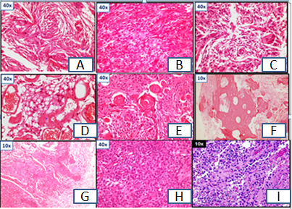
Figure 1: Variants of Meningioma, Hand E Stain.A:Meningothelial,B: Fibroblastic, C:Transitional, D:Angiomatous, E: Psammomatous, F: Metaplastic, G&H :Atypical with brain parenchymal invasion, I:Papillary.

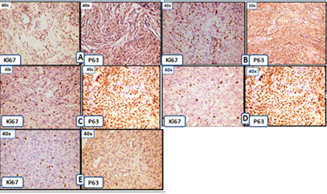
Figure 2:A Grade I Meningothelial Meningioma low Ki67 LI(3%),P63<10%,B: Grade I High Ki67 8% LI and P63(3+) Positivity,C: Grade 2 Atypical Meningioma,Raised Ki67LI(8%), P63(3+),D:Grade 2 Atypical Meningioma Low Ki 67 LI (1%) with high P63(3+),E: Papillary Meningioma,High Ki67 LI(9%) and P63(3+).

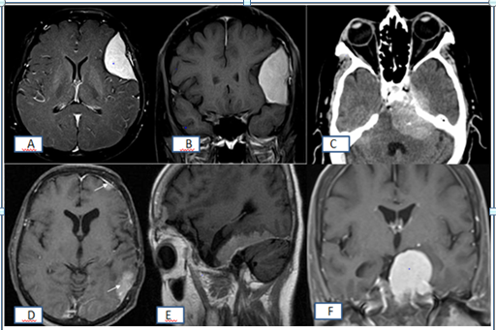

Figure 3:Radiologic images depicting various sites of Meningiomas.A: T2W MRI Saggital section showing fronto-temporal lesion with dural enhancement.B:T1W MRI Coronal section showing parieto-temporal lesion with dural enhancement, C: CT image showing basally located dural enhancement.D:T1W MRI Sagittal section showing parieto –occipital dural lesion.E:T1W MRI Coronal section showing tentorial enhancement.F: T1W MRI Coronal section showing falx cerebri dural enhancement.

